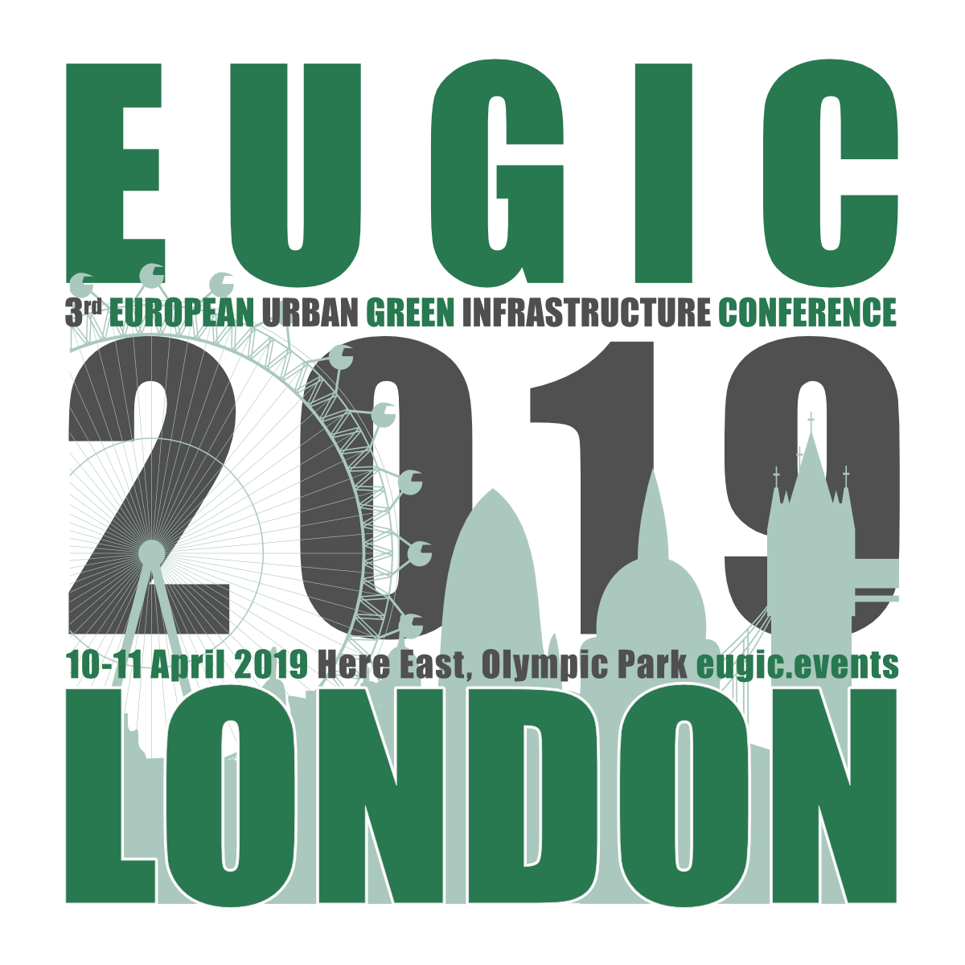

EUGIC 2019 London Awards - Call for Posters
www.eugic.events/call-for-posters-2019

Entry Deadline: Monday 18 March 2019
Notification of Finalists for exhibition: 25 March 2019
EUGIC 2019 London Awards Ceremony: 10 April 2019

We are looking for the most innovative, interesting and creative green infrastructure projects, policies, strategies and research for urban climate change adaptation. Finalists will be selected by EUGIC's Expert Jury and exhibited at EUGIC 2019 London 10-11 April 2019, with Awards Ceremony on 10 April 2019.

Entry Criteria
Posters must be vertical A1 format in one of four categories:
- Implemented urban green infrastructure projects and the ecosystem services provided
- Urban strategies, policies, governance or assessment methods to deliver green infrastructure
- A conceptual vision for urban green infrastructure in Europe or around the world
- Research on nature-based solutions for cities applicable in Europe

Format Vertical A1 (594mm wide X 841mm high)
Poster language English
Presentation Printed poster
Participation Presenters must be available to discuss their work during EUGIC 2019 London on Wednesday 10 and Thursday 11 April 2019 and share relevant information with participants about the work
Number One poster per entry, unlimited entries
Publication Finalists will be published on the EUGIC website and in the conference brochure, with authors, co-authors and partnering organisations
Exhibition Finalists will be exhibited during EUGIC 2019 London
Description Short: 50 words maximum
Long: 200 words maximum
Entry Deadline Monday 18 March 2019
Selection Posters finalists will be selected for the Awards and exhibition by an Expert Jury
Notification Finalists will be notified by Monday 25 March 2019 if they have been selected for the EUGIC 2019 London Awards and Exhibition
Registration If your Poster is selected, you will need to show proof of conference registration.> Register here…
EUGIC 2019 London Poster Entry Form

Please email your Poster, thumbnail and Entry Form to info@eugic.events by 18 March 2019
with subject line ‘EUGIC 2019 London Call for Posters‘

* Required field. Boxes expand as you write.

POSTER ENTRY
Title*
Presentation Format  A1 Vertical (594mm wide x 841mm high) |  | I confirm poster is A1 vertical format
Short Description*
Maximum 50 words

Long Description*
Maximum 200 words
Five keywords*
Associated with your work
Category*  Indicate the focus that best represents your poster topic |  | Implemented urban green infrastructure project  Policy, strategy, assessment tool or approach  Creative vision, concept or theory  Nature-based solutions for cities research
Weblink(s)
UPLOADS/ATTACHMENTS
Poster Thumbnail* (max 500KB) |  | I confirm this is attached
Poster* (max 5MB) |  | I confirm this is attached
PRESENTERS & PARTNERS
Primary Contact
Name and title*
Role*
Organisation(s)*
Contact Email*
Contact telephone and country code
Any co-presenters’ titles, names and organisations
Brief description of all presenter(s)
Bios/Profiles - Maximum 100 words in total
List any partnering organisations*
Site/location of poster focus (city/ies and country/ies)*
FURTHER INFORMATION
EUGIC 2019 London |  | www.eugic.events
EUGIC 2019 London Call for Posters |  | www.eugic.events/call-for-posters-2019
EUGIC 2019 London Registration |  | www.eugic.events/register-now/
Contact EUGIC with any questions |  | info@eugic.events

EUGIC 2019 London – the 3rd European Urban Green Infrastructure Conference – is organised by the EUGIC Team in association with a wide range of partners and supporting organisations and co-hosted by The Bartlett, UCL and Loughborough University London at Here East in the Queen Elizabeth Olympic Park.
www.eugic.events

